Contribution Title „English” (TIMES NEW ROMAN 14, Bold)
Contribution Title „Hungarian or other”
FIRST Author - SECOND Author (TIMES NEW ROMAN 12, BOLD)

Abstract (english) (TIMES NEW ROMAN 10, bold)
The abstract should summarize the contents of the paper in short terms, i.e. 200-300 words.
Keywords: First Keyword, Second Keyword, Third Keyword. (TIMES NEW ROMAN 10, italic)

Abstract (hungarian or other language)
The abstract should summarize the contents of the paper in short terms, i.e. 200-300 words.
Keywords: First Keyword, Second Keyword, Third Keyword.
FIRST SECTION (TIMES NEW ROMAN 12, BOLD)
Please note that the first paragraph of a section or subsection is not indented. The first paragraphs that follows a table, figure, equation etc. does not have an indent, either.
Subsequent paragraphs, however, are indented. (TIMES NEW ROMAN 12 normal)
Table 1. Table captions should be placed above the tables.
Heading level | Example | Font size and style
Title (centered) | Lecture Notes | 14 point, bold
1st-level heading | 1 Introduction | 12 point, bold
2nd-level heading | 2.1 Printing Area | 12 point
Displayed equations are centered and set on a separate line.
x + y = z (1)
Please try to avoid rasterized images for line-art diagrams and schemas. Whenever possible, use vector graphics instead (see Fig. 1).
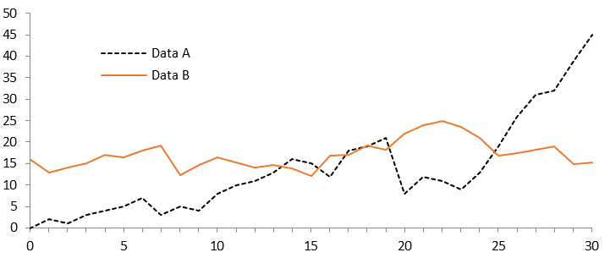
Fig. 1. A figure caption is always placed below the illustration. Short captions are centered, while long ones are justified.
For citations of references, we prefer the use of square brackets and consecutive numbers. Citations using labels or the author/year convention are also acceptable. The following bibliography provides a sample reference list with entries for journal articles [1], an MARE chapter [2], a book [3], proceedings without editors [4], as well as a URL [5].

References
- Author, F.: Article title. Journal 2(5), 99–110 (2016).
- Author, F., Author, S.: Title of a proceedings paper. In: Editor, F., Editor, S. (eds.) CONFERENCE 2020, LNCS, vol. 9999, pp. 1–13. Mare, Velence (2022).
- Author, F., Author, S., Author, T.: Book title. 2nd edn. Publisher, Location (1999).
- Author, F.: Contribution title. In: 32th International Proceedings on Proceedings, pp. 1–2. Publisher, Location (2020).
- MARE Homepage, http://www.mare.hu, last accessed 2022/07/01.

Please send your presentation by 01.10.2024 at the latest to the following email address (daruka.norbi@gmail.com). We reserve the right to make stylistic changes in the case of incorrectly edited material!!!

Unit; profession, email adress; ORCID: 1111-2222-3333-4444.
Unit; profession, email adress; ORCID: 1111-2222-3333-4444.

